## Component behaviour

Each component can have its own behaviour. Sometimes it is just representing a value and sometimes there is some extra functionality available. The following examples will give you an idea of some of the possibilities.

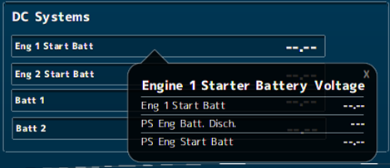

Figure 4‑1: Pop-up balloon

When you double-click on a value, a balloon will pop up with some additional information (see Figure 4‑1).

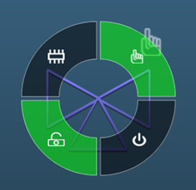

Figure 4‑2: control doughnut

When you click on items that you can control, a radial menu will appear. Depending on the element and its settings, you can control different aspects of the item (see Figure 4‑2). For the control elements, see Tables 8, 10, 11 and 12.

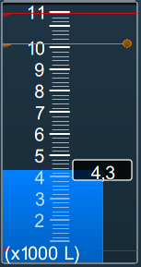

Figure 4‑3: Vertical bar with alarm lines

In the vertical bars (often used for tanks) you can see the warning and critical alarm levels. The critical alarm levels (red) are not changeable since these are mandated by class. The warnings (orange) can be changed by dragging the lines with your mouse on the little dot at the end of the line. This way, you can use it for example when filling a tank. You get a warning (visual and audible) when the warning line is crossed.

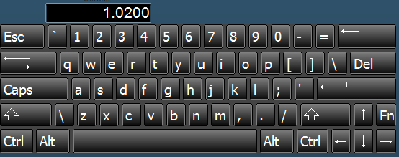

Figure 4‑4: Edit keyboard

When you have an *edit-enabled* value, you can click on it and a keyboard will appear (see Figure 4‑4). You can fill in an amount and press enter to change the desired value. It will not be possible to change it beyond the min/max values.

|  |  |  |
| --- | --- | --- |
| **Status** | **Control element** | **Symbol** |
| Operable in two speeds, system off | Double chevron (no fill) |  |
| Operable in two speeds, system running at low speed | Double chevron (single chevron filled) |  |
| Operable in two speeds, system running at high speed | Double chevron (double chevron filled) |  |
| Operation is disabled (local control only or controlled by other OPC) | Padlock |  |
| Manual operation (controlled remotely) | Hand |  |
| Automatic operation (controlled by ACS[1]) | Chip |  |

Table 8: Control element status

|  |  |
| --- | --- |
| **Colour** | **Description** |
| **Grey** | Control element off (stopped), device is ok |
| **Green** | Control element on (running), device is ok |
| **Orange** | Control element in warning condition |
| **Purple** | Control element defective |
| **Red** | Control element in alarm condition |

Pump and generator control elements

|  |  |  |  |
| --- | --- | --- | --- |
| **Centrifugal pump** | **Piston pump** | **Generator** | **Status description** |
|  |  |  | Off |
|  |  |  | On (condition ok) |
|  |  |  | On, warning condition |
|  |  |  | On,  defective condition |
|  |  |  | On,  critical condition |

Table 9: Control elements and color animation

|  |  |  |  |
| --- | --- | --- | --- |
| **3-way valve OFF** | **Status description** | **3-way valve ON** | **Status description** |
|  | 3-Way valve off (status indication only) |  | 3-Way valve on (status indication only) |
|  | 3-Way valve off, auto (control by AMCS[2]) |  | 3-Way valve on, auto (control by AMCS) |
|  | 3-Way valve off, auto  (local control) |  | 3-Way valve on, auto  (local control) |
|  | 3-Way valve off (local control) |  | 3-Way valve on  (local control) |
|  | 3-Way valve off, manual (controlled by AMCS) |  | 3-Way valve on, manual (controlled by AMCS) |
|  | 3-Way valve off, manual (local control) |  | 3-Way valve on, manual (local control) |

Table 10: Control elements with status indication

|  |  |
| --- | --- |
|  | Centrifugal pump on,  operable in two speeds, system off |
|  | Centrifugal pump on,  operable in two speeds, pump running at low speed |
|  | Centrifugal pump on,  operable in two speeds, pump running at high speed |

Table 11: Control elements with speed indication

|  |  |  |
| --- | --- | --- |
|  |  | Fan off & on |
|  |  | 2-way valve off & on |
|  |  | Check valve off & on |

Table 12: Other control elements

1.
2.